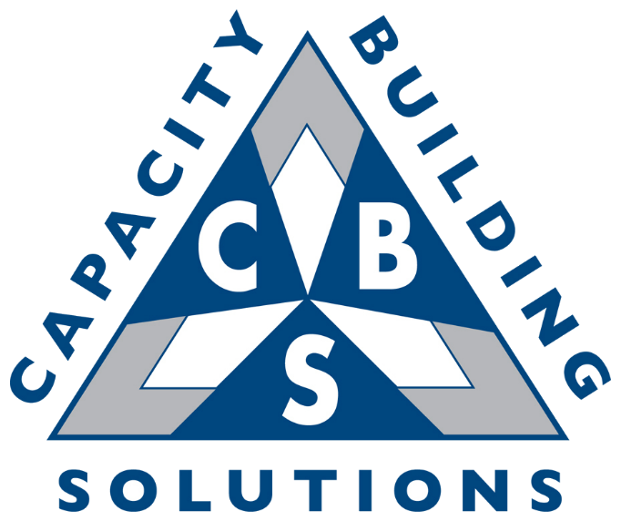

CEO Coaching Client
2021 Review and 2022 Goal Planning

DO---HAVE ---BE

Who do I want to BE (What kind of person)?

What do I want to DO? (What activities are most fulfilling; Where will I spend my time?)

What do I want to HAVE? (Material Possessions)

One Word Exercise

 | One word that describes me today? (2021) | How I want to be described in 2022?
Leader
Businessperson
Boss/Manager
Philanthropist
Community Leader
Neighbor
Spouse
Parent
Sibling
Child (if parents are still alive)
Friend

REFLECTION QUESTIONS

PERSONAL:

What is the most helpful thing you could tell us about the current state of your personal life?

What is the story you’d like to write about your personal life in 2022?

What’s the one thing you could do as family member to make everything else easier or unnecessary for the people you love?

What decisions are you avoiding? What’s preventing you from making them?

What threatens your peace? Your health? Your personal fulfillment?

What are your personal financial objectives? Are you on track?

What is the impact you would like to make in your community?

How can you better leverage your Vistage relationship to address all the above?

Please Rate Your 8 Basic Life Areas (1-10 with 1 being failing and 10 being fully content):

Area | Importance to You (1-10) | Current Rating (1-10)
Work
Money
Family
Personal Growth
Health
Community Involvement
Friendships/Social Life
Spiritual

In which Life are would you like to most improve in 2022?

Personal Data

How Often Do You Exercise (circle)? Daily 3x per week 1-2x per week Sporadically Rarely

Date Night (circle): 1-2x per week 1x per week Bi-weekly Monthly Rarely Never

Last Vacation: How Long?

Next Vacation: How Long?

Last medical/physical:

Next medical/physical:

Current weight: Goal weight:

BUSINESS:

What is the most helpful thing you could tell us about the current state of your organization?

What has become clear about your business role and/or life over the past year?

What is the story you’d like to write about your impact on the business in 2022?

What are your biggest knowledge/skills gaps as a leader?

What decisions are you avoiding? What’s preventing you from making them?

What big strategic questions do you have about your business as you plan for 2022?

Do you have the right team around you to execute on your business vision for the next 1-3 years? If not, what are you doing about it?

What’s the one thing you could do as business leader to make everything else easier or unnecessary in your company?

High Level Business Results:

 | 2021 Plan | 2021 Actual | 2022 Plan | 2025 Plan
Sales/ Revenues | $450K | $460K | $500K | $750K
# of Employees
Sales/Revenue per Employee
Cost of Goods Sold/Cost of Sales %
Gross Profit %
Pre-tax Profits

What do you feel were YOUR most significant accomplishments (personal and/or professional) in 2021?

What do you feel were Your Company’s/Companies’ most significant accomplishments in 2021?
See above

What do you feel were YOUR most significant disappointments (personal and/or professional) in 2020?

What do you feel were Your Company’s/Companies’ most significant disappointments in 2021?
See above

2021 Business GPA Rankings (Please use letter grades and provide an explanation)

- Growing Revenue from New Customers

- Maximizing Revenue from Existing Customers

- Managing Operations Effectively to Maximize the Bottom Line

- Creating a Work Environment That Attracts and Retains Talent

- Consistently Meeting or Exceeding Customer Expectations

- Creating A Culture of Innovation Throughout the Company

Key Performance Indicators for my business
(besides revenue and profit, examples provided):

Key Performance Indicator (KPI) | 2021 Target | 2021 Actual | 2021 Variance | 2022 Target
Full Groups

Member Retention

Non-Vistage revenue %

Monthly Revenue

Credit Card Balances at A Minimum

What is the current cash position of the company? What is your financial runway?

How much debt are your currently carrying? How well can the business service this existing debt?

Do you plan on making any business acquisitions in the next 1-3 years? If so, how will you make this happen?

If you were competing against your company, what would you do?

What are my Big Three focus areas as a leader in 2022?

CEO ROLES (IF APPLICABLE):

How Are you performing against the following core CEO Roles?

- Chief Strategist – providing clear strategic direction for the company

- Chief Team Builder – placing the right key people in the right spots and having them interact in the right way

- Chief Sales Officer – ensuring the organization has a consistent and scalable sales system/process and helping to close BIG deals

- Chief Accountability Officer? – ensuring there are systems and processes in place to hold departments and people accountable

- Chief Culture Officer – institutionalizing the core values throughout the company and serving as their role model

- Chief Coach/Mentor – doing a great job coaching and mentoring your direct reports and expecting the same of them

Exit Planning Question:

Until what age do you expect to work full time?

Do you have a natural successor(s)? And, if yes, how are you cultivating his/her skills? If no, what is your plan to find or grow someone into this role?
- No, not sure if this is applicable to me

Exit strategy Yes No

Succession Plan Yes No

Other Reflection Questions:

What are you passionate about pursuing as a leader? And, how much time are you spending on this?

What are your strongest talents as a leader? And, how much time are you spending doing these things?

If you could find 5 more hours per week in your schedule, what would you spend it on and why?

If you had unlimited resources to invest in your business, what would you do with them? Why?

What is motivating you right now – either dissatisfaction with the status quo or excitement about the future? Why?

BEING GRATEFUL

The hardest arithmetic to master is that which enables us to count our blessings. ~Eric Hoffer, Reflections On The Human Condition

This past year has been a difficult journey for many. As we enter a new year with more expected challenges ahead of us, let’s take some time to reflect on who and what we are grateful for.

Describe gratefulness:

What is it that makes you feel grateful?

As we express our gratitude, we must never forget that the highest appreciation is not to utter words, but to live by them.—John F Kennedy

Now how are you going to show your gratefulness? Be specific, who and what…

What I can do to get the most out of my coaching experience:

2022 Primary Goals

Name: Ed Robinson

“Smart” Goals are: Specific, Measurable, Attainable, Realistic, Timely

What are your 4 primary business goals?

Goal | Metric:  How will you measure success? | Timeframe Completed by:

What are your 4 primary personal goals?

Goal | Metric:  How will you measure success? | Timeframe Completed by:

