Leadership Discussion Document
Offense or Defense?

The current state of your business:
- Is the market growing or contracting?
- Do you have more or less competition?
- Are your margins growing or contracting or performing as expected?
- Is your cash flow growing or contracting or staying constant?
- Do you have too many or too few employees or the right number?
- How well is your supply chain functioning? Are material delays significantly affecting your operational efficiency?
- Is your sales pipeline growing or contracting?
- Is the sales cycle expanding or contracting or staying consistent?
- Is the average sale size/amount growing or contracting or staying the same?
- Is your work backlog/WIP growing or contracting?
- How well diversified are you from a market, client, or product/service basis? Can you withstand a major loss in any one of these categories?
- Is M&A activity increasing or decreasing in your market? What does this mean for you?
- How are you integrating interest rate dynamics into your economic model?
- How do you think Artificial Intelligence will affect your business model in the next 1-3 years?
- Do you have the leadership team in place to navigate the current climate? If not, where are your gaps and what can you do about it?

What is your take on the next two years related to all of the above?

Given the above, do you see yourself playing more offense or defense as a leader?

Please list in what ways you are currently playing either offense or defense as a business leader:

Offense | Defense
How should your business be playing the game over the next 1-2 years? What’s missing from your current approach?

Where do you see your company and you as a leader on the organizational lifecycle?

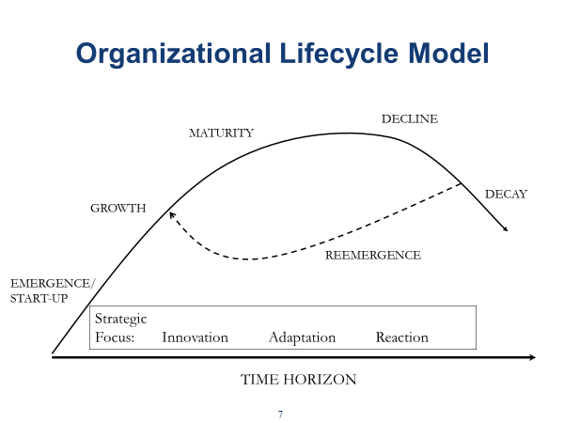
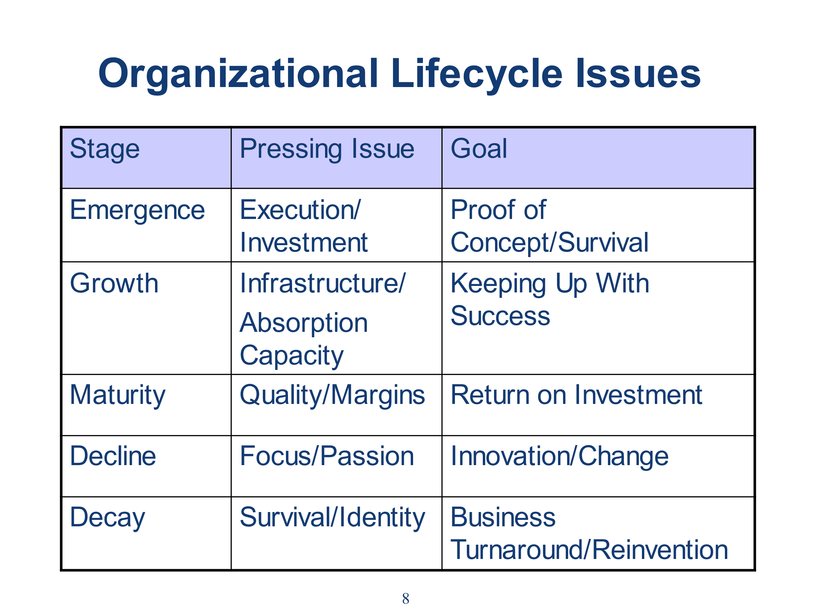
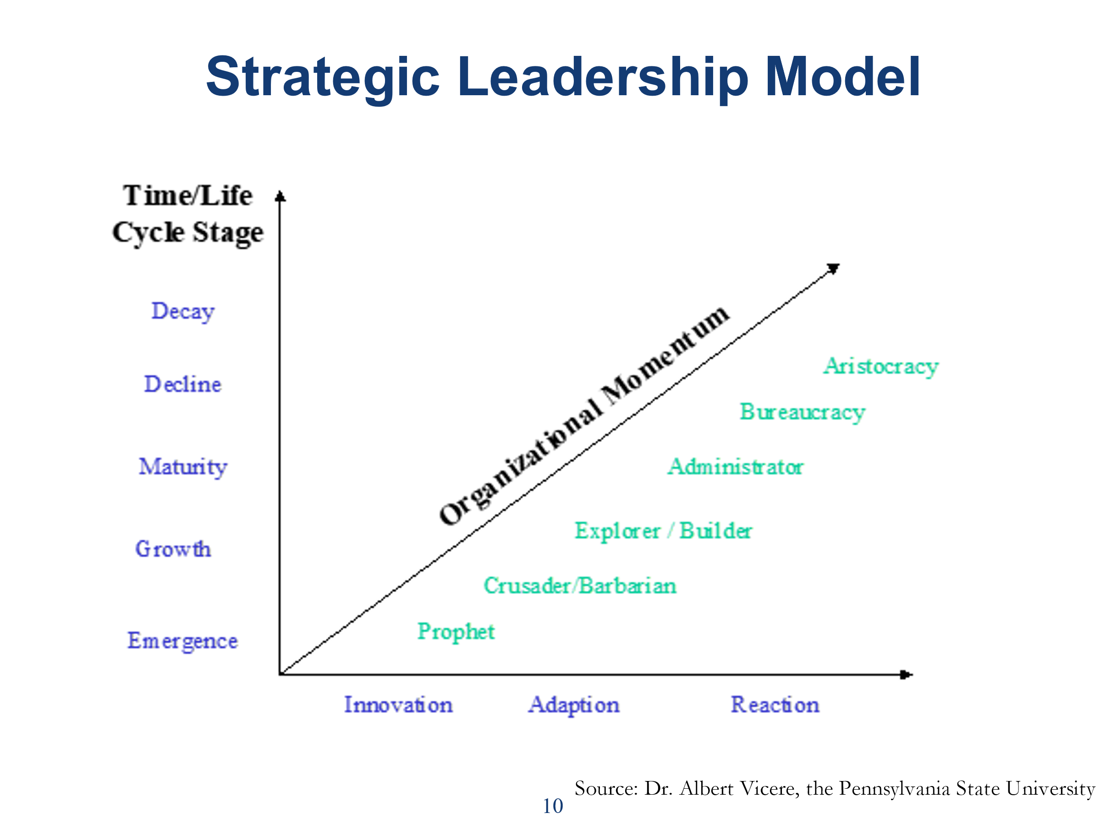
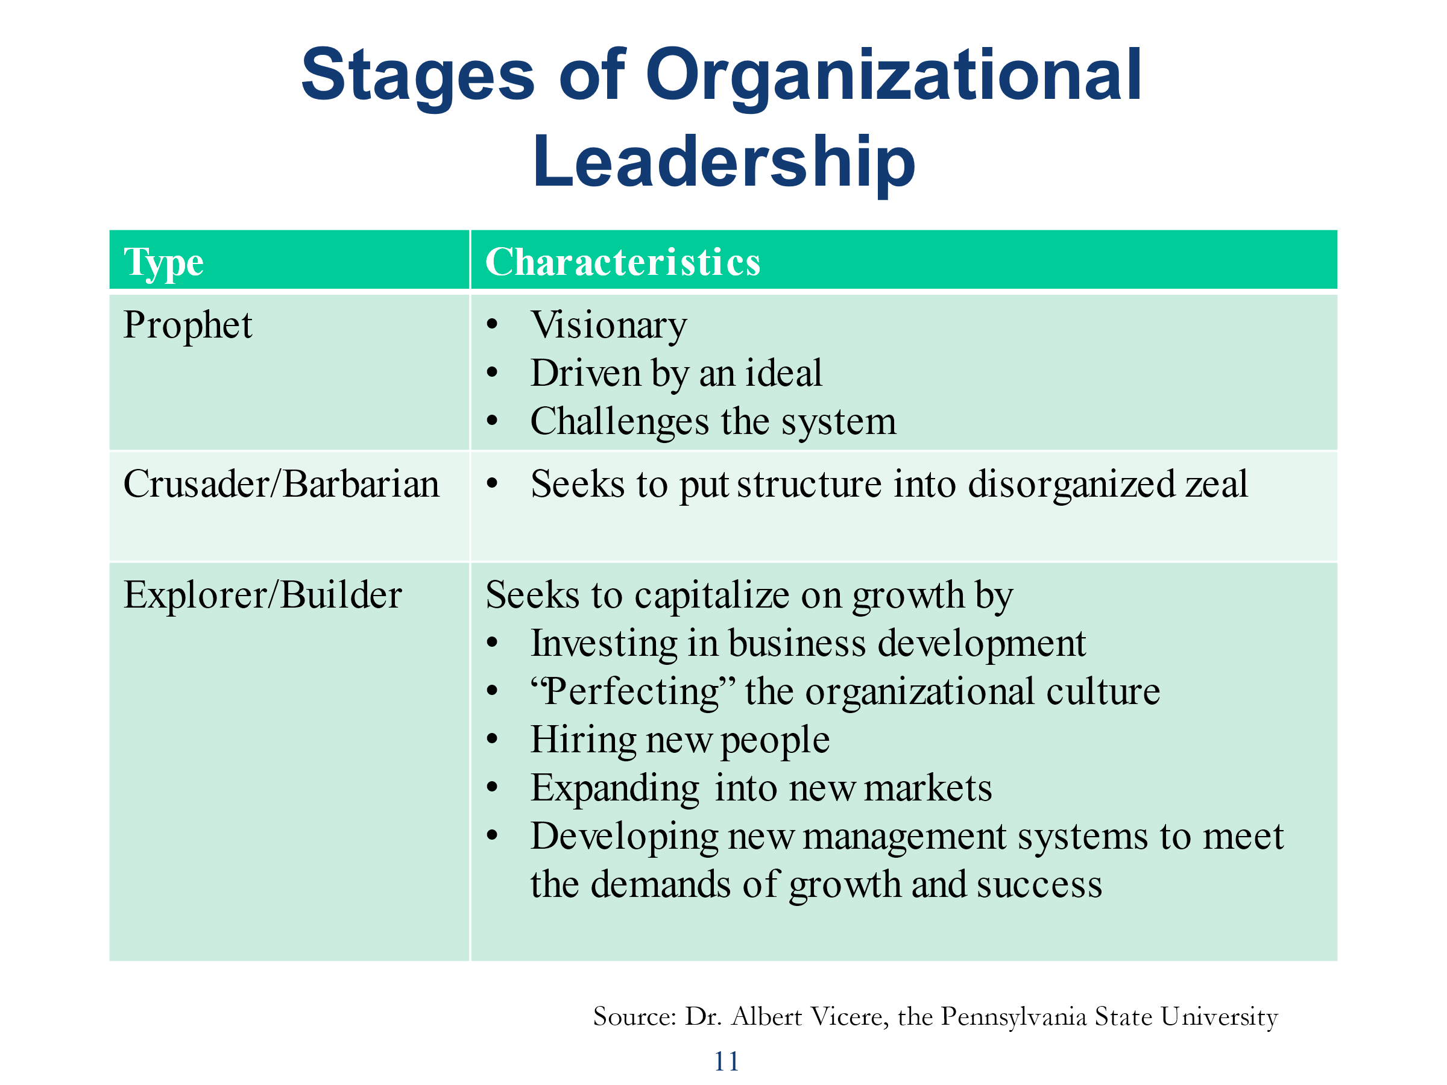
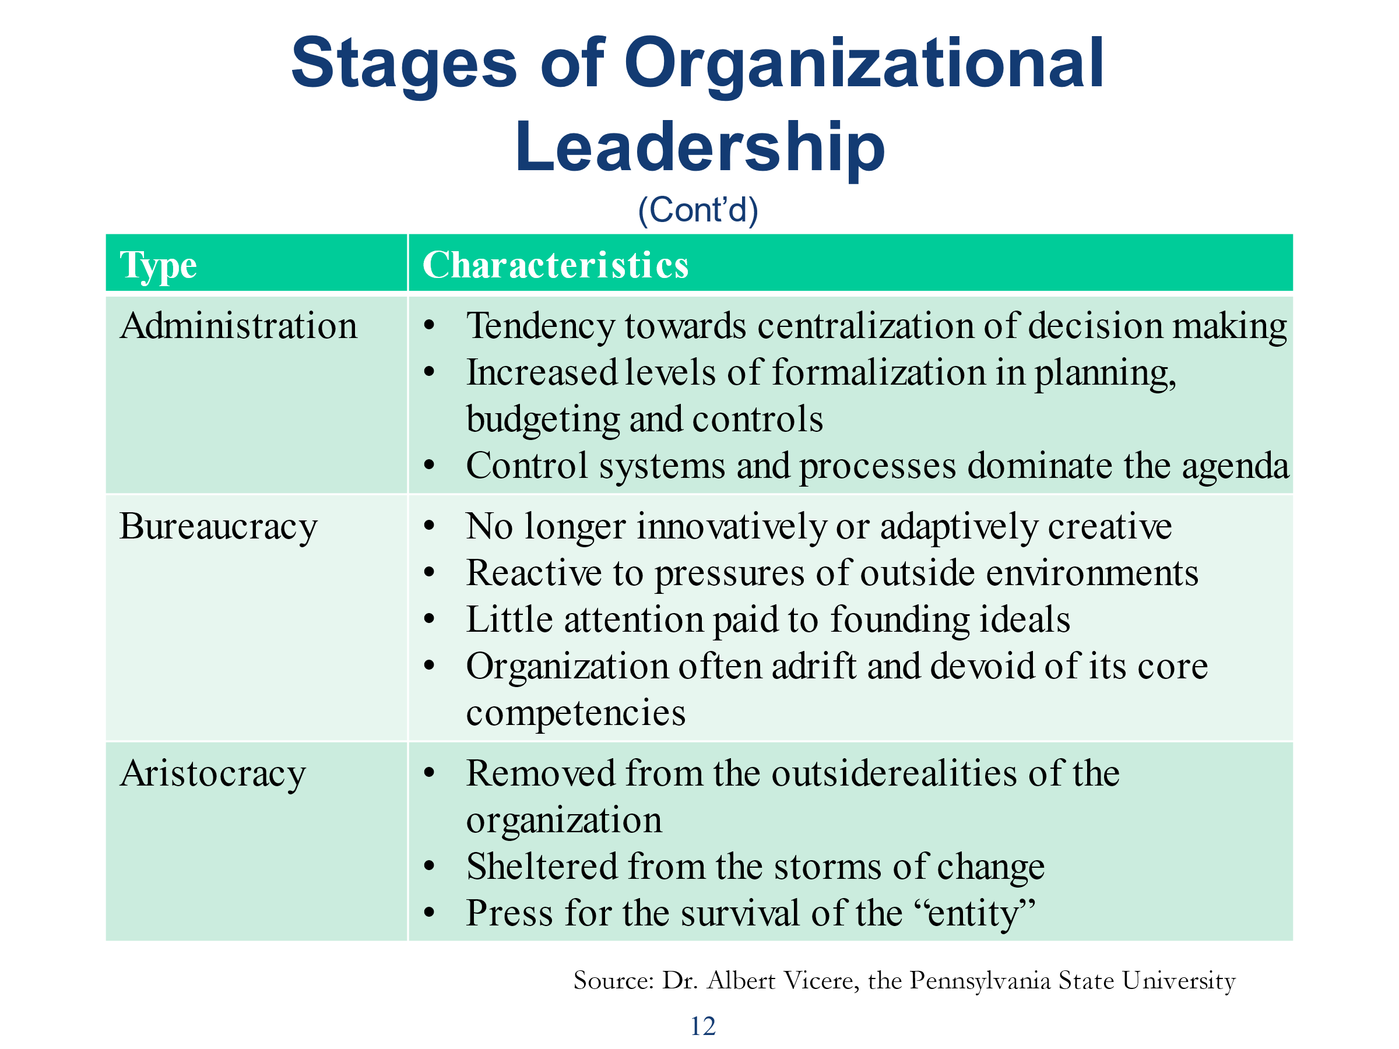
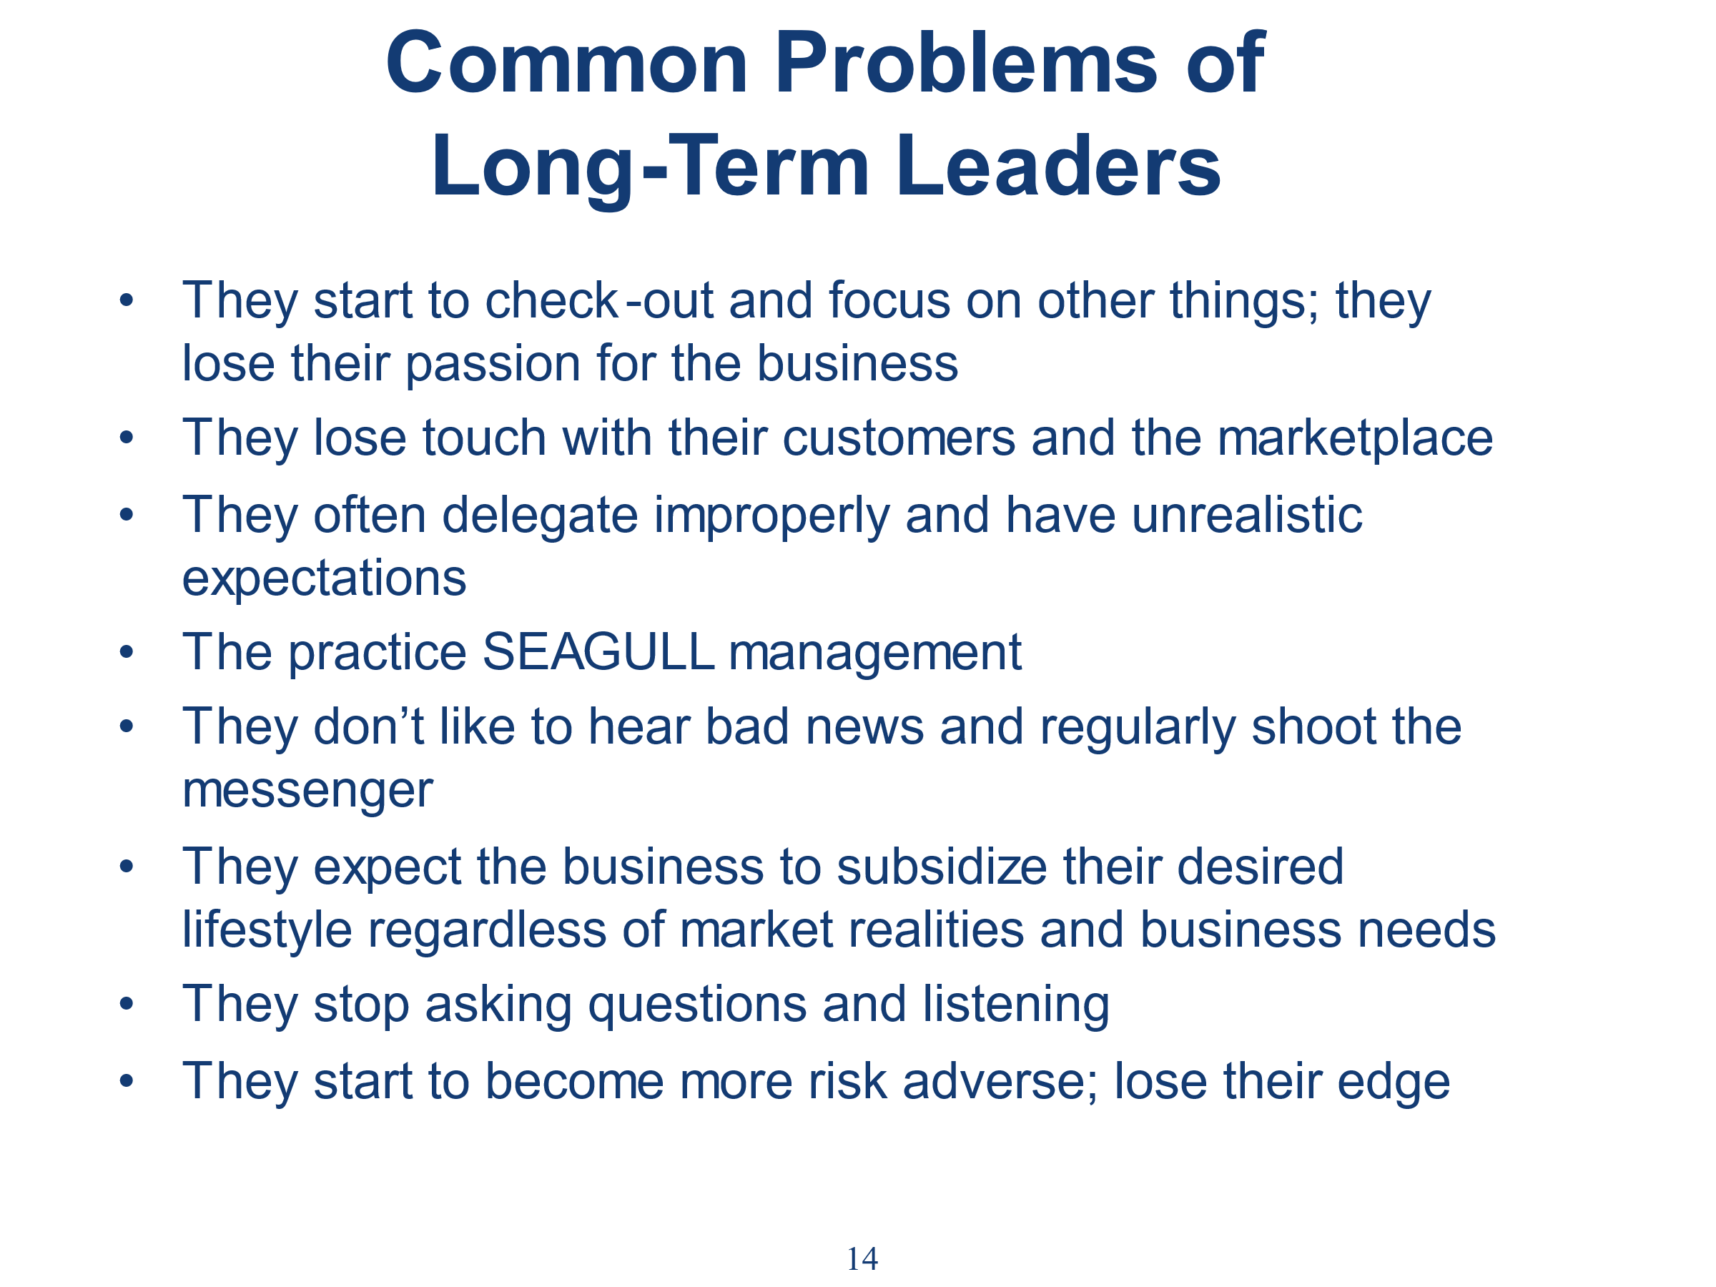
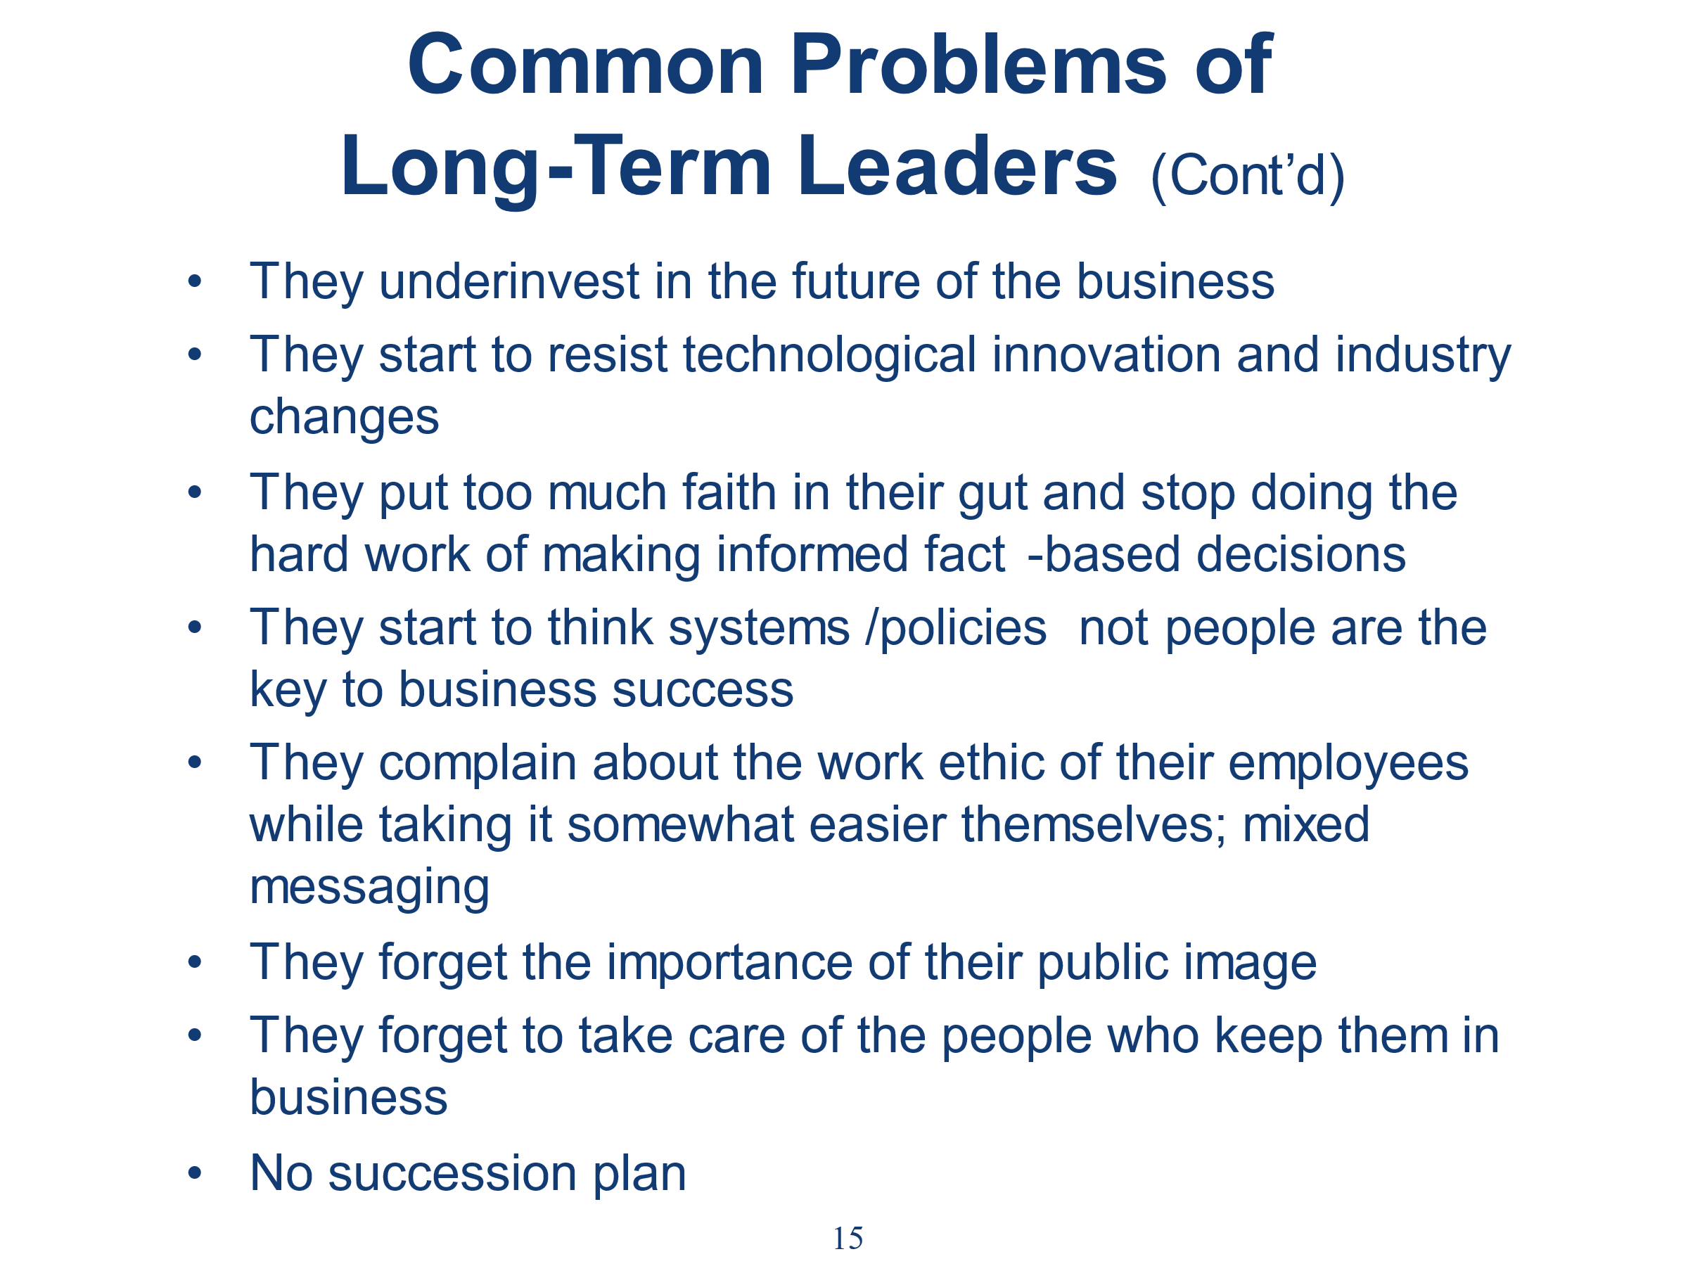

Can you think of any other problems of long-term leadership?

What are your current obstacles/problems as a leader?

Do you still have a high level of passion for your business?

Are you effectively leveraging the talents you have as a leader for the business?

How do you need to change/reinvent yourself as a leader to successfully meet the needs of the business in the current and near-term economic environment?

What is the biggest question you have about your business right now?

